**Crime Breakdown in Chicago**

**Principal Investigator: Brandon Domash (bdomash@wisc.edu)**

**Purpose of Study**

In this study, I examine the characteristics of Chicago’s crime data. To many Americans, Chicago is known as one of the most dangerous cities in America, especially when it comes to violent crime and homicides. The high crime rates in Chicago are frequently discussed and are common talking points of local news broadcasts as well as politicians on a national scale. This has been especially true over the past few years, as Donald Trump has made the high crime rates of Chicago a regular talking point of his campaign and presidency. During his campaign, Trump even said he could “solve crime problem in a week if cops got tougher” [1].He also made claims that crime in Chicago and other big cities is “rapidly getting worse” [2].

In exploring Chicago’s crime data, I examine how crime volume and patterns have changed over time to see if the data supports Trump’s claim that crime is rapidly getting worse. In addition, I take a closer look at the crime data in 2017 to investigate what types of crime are most commonly reported and where crimes occur within Chicago.

Many activist and civil-rights organizations, such as the NAACP and ACLU, have claimed that both minorities and people of lower socio-economic status are disproportionately arrested throughout America, especially when it pertains to drug offenses [3][4]. As a part of my analysis, I analyze how crime in Chicago relates to the demographics and socio-economic conditions of Chicago. In addition, I looked closer at reported crimes relating to drug offenses, particularly where these offenses are most common. I find that drug offenses, particularly small amounts of marijuana possession, are most common in the poorest communities of Chicago, particularly communities with a high proportion of Black residents.

**Analysis**

The bulk of the data used for this report comes directly from the city of Chicago’s data portal, in which the city provides a database with information on all reported incidents of crime from 2001 to present, minus the most recent seven days. The dataset is rather large, containing 6.76 million rows of data, one for each reported crime over this time frame. The data includes lots of information regarding each incident, including the date, location (classified in many different ways), the primary and secondary crime type (ex: robbery would be the primary crime type, armed: handgun would be the secondary crime type), whether or not an arrest was made, and the coordinates of the incident.

The unit of observation I focus on for my analysis is Chicago’s “Community Areas”. Chicago is broken up into 77 community areas, which make up the 9 different “Sides” of Chicago (North Side, South Side, West Side etc.). In addition, I gather socio-economic data and demographic data for each of the communities and merge this data together with the crime data. I start by looking into Trump’s claim that crime in Chicago is rapidly getting worse.

1. **A Brief Overview of Crime in Chicago, 2001-2017**

I first group the crime data by year, looking at both the total number of reported crimes as well as the number of arrests. As clearly shown in *Figure 1*, both the total number of reported crimes as well as the number of arrests have steadily decreased since 2001. There appears to be a slight uptick in crime in reported crime in 2016, however the general trend appears to be that incidents of crime and arrests are decreasing.

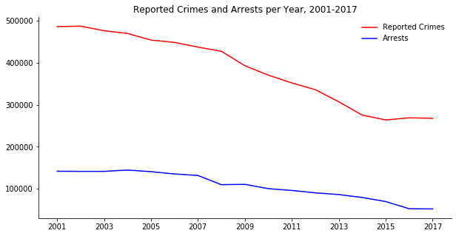

Figure

Next, I take a look at how certain types of arrests have changed over time. In particular, I am interested in the patterns of violent crime in Chicago as well as the patterns of crime related to drug use in Chicago. In tracking violent crime, I grouped all arrests relating to homicide, criminal sexual assault, robbery, battery, assault, burglary, and arson together, as they are each defined as violent crimes by the Illinois statutes and general assembly [5]. All crime classified under narcotics is used to track drug offenses. Looking at *Figure 2* shows a clear decrease in both drug arrests as well as arrests for violent crimes since 2001.

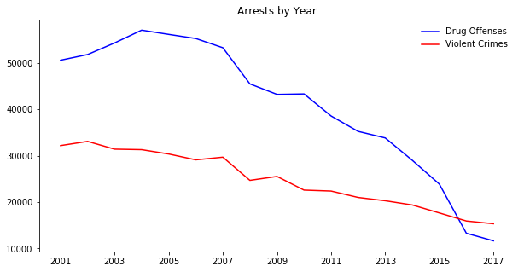

Figure

It is particularly interesting, but not necessarily surprising, to see how greatly arrest for drug offenses have declined this century, and 2016 marked the first time this century that there were fewer arrests for narcotics than for violent crimes. A much more relaxed view towards drugs, particularly marijuana, could be the key reasoning we see this trend in the data, although in theory it could also be due to there being fewer drug users today. I then grouped drug offenses for 2001 and 2017 by their secondary description, which states exactly what the drug offense is. *Table 1* shows the top five most common drug arrests in 2017, and *Table 2* shows the top five most common drug arrests in 2001.

Table



Table



You can see the huge disparity in both Cannabis possession offenses as well as Crack possession offenses from 2001 to 2017. Alone, those two categories have dropped by nearly 25,000 this century, a large reason why drug offenses have decreased so much this century. Besides the great decrease in drug offenses, there does not seem to be major differences in the types of crimes reported or the types of arrests.

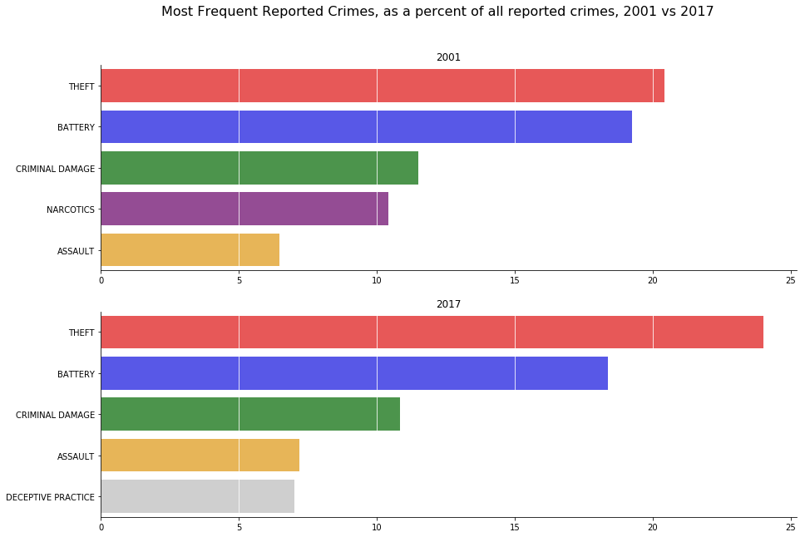

Figure

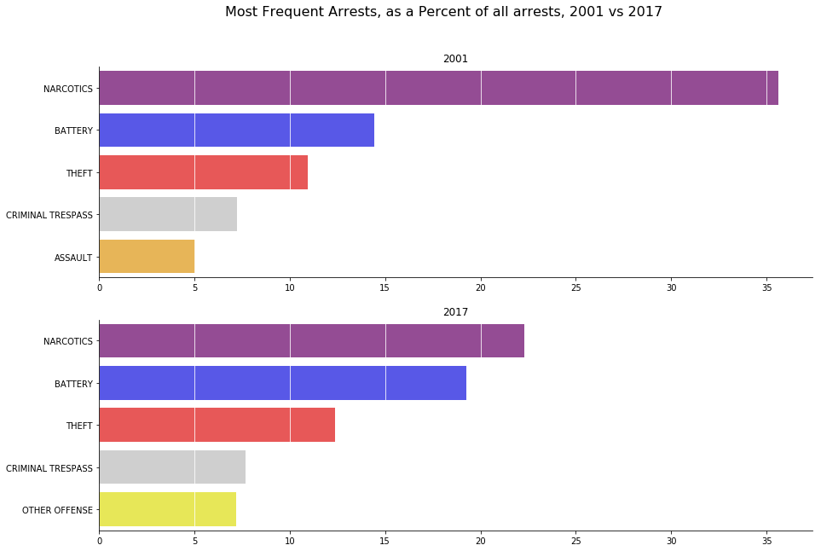

Figure

Figures 3 and 4 show the most common crimes reported in 2001 vs 2017 and the most common arrests in 2001 vs 2017, respectively. We confirm that drugs are a much smaller proportion of the crimes committed, as they are no longer in the top five most common crimes reported. Drugs do still account for the greatest proportion of arrests; however they now only make up around 22% of all arrests vs the 36% of arrests that drugs accounted for in 2001.

1. **Chicago Crime Characteristics, 2017**

Many people tout Chicago as the murder capital of America, and the high crime rate is also a deterrent for many coming to the city. *Figure 5* displays the distribution of reported homicides in 2017.

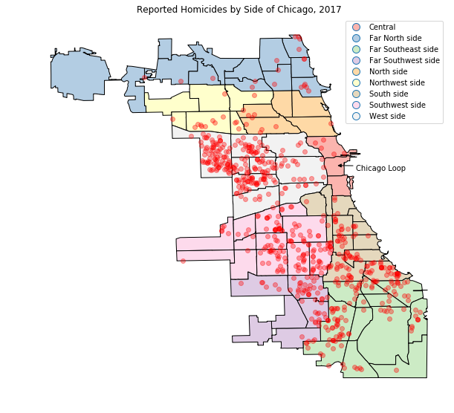

Figure

Homicides appear to be heavily clustered in Chicago, with nearly all homicides being reported from Chicago’s western and southern sides. Downtown Chicago, also known as “The Loop” appears to have no reported homicides in 2017, and most northern communities of Chicago also appear rather unscathed by homicides. It appears that one should stay out of the southern and western sides of Chicago to avoid crime. *Figure 6* below displays the ten communities with the most violent crimes per capita, all of which come from Chicago’s West side, Southwest Side, South side, and Far Southeast side.

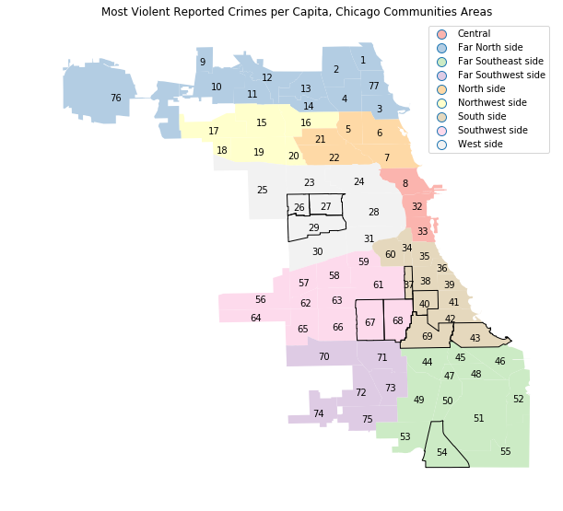

Figure

The reason for this distribution of crime can be explained by the city’s demographics and socio-economic breakdown. Figure’s 7 and 8 look at how demographics and socio-economic status is broken down at the community level.

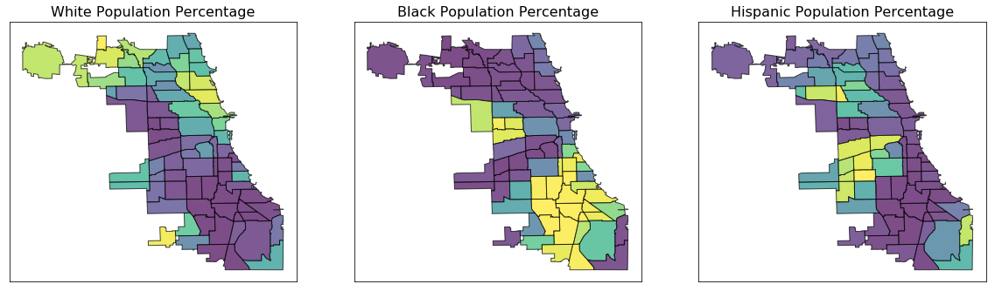

Figure

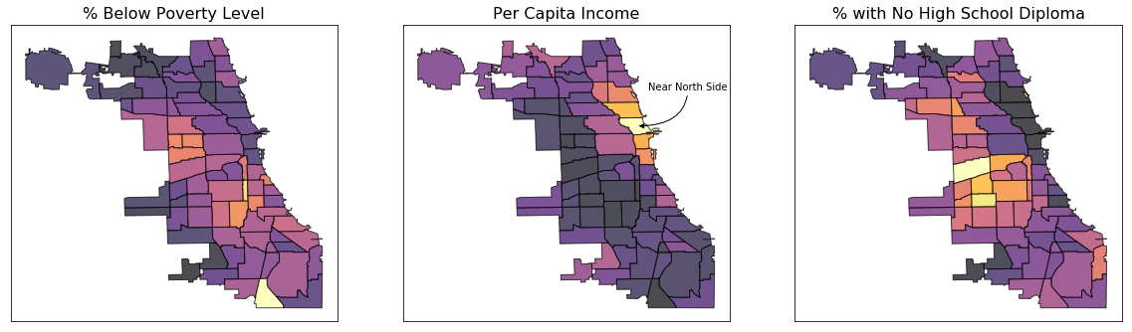

Figure

Starting with demographics, white people almost exclusively live in the northern and northwestern areas of Chicago, which are also the areas least impacted by high amounts of violent crimes. On the contrary, Chicago’s southern areas are known for being primarily black and Hispanic people communities. As for socio-economic status, there is a much higher density of households below the poverty line as well as people with who have not graduated high school Chicago’s southern and western communities. We also see that the richer communities are those on the north side of Chicago, with the ‘Near North Side’ community having then highest per capita income in Chicago. *Figure 9* displays how this relate to crime.

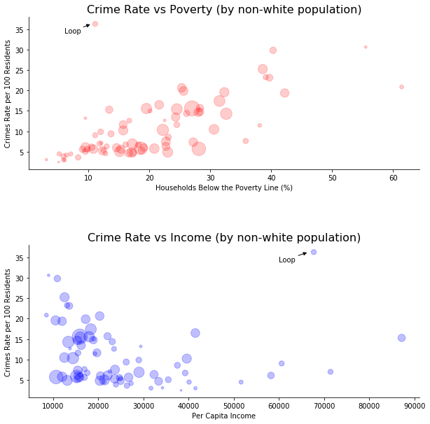

Figure

In the top graph we see a clear direct relationship between the percentage of households below the poverty line and the crime rate. We also see from the size of the points that communities with a higher poverty rate also have a higher non-white population. The bottom graph tells the same story, but with per capita income. We see the Loop has a high crime rate, but this is likely because this is the center of business and tourism for Chicago, thus many Chicagoans work in this area and not many live there, creating a high crime rate per residents.

Next we look at the distribution of all crimes and arrests in Chicago, shown in *Figure 10.*

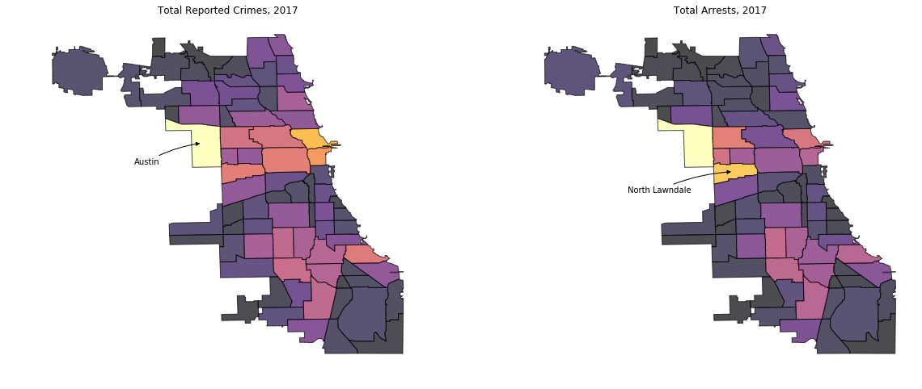

Figure

This confirms what we have already seen above, as most reported crimes and arrests come from Chicago’s western and southern communities. *Figure 11* below breaks down reported crime into violent and non-violent incidents, and the results are similar. One interesting thing to note is the high amounts of non-violent crime in central Chicago, as the Loop and Near North Side, two of the richest communities, have some of the highest amounts of non-violent crime. Another interesting thing to note is the high prevalence of crime in Austin, which is near the top in total both non-violent and violent crimes.

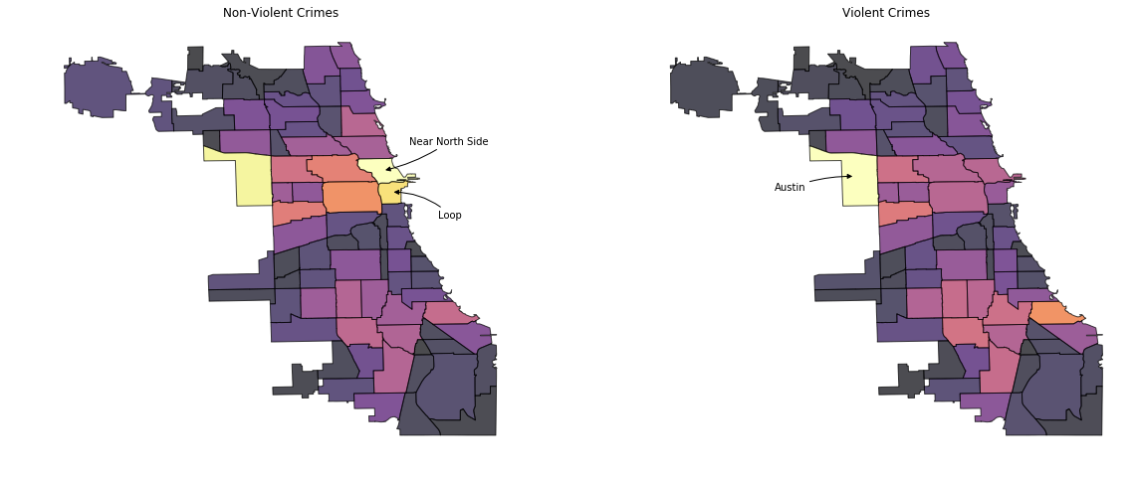

Figure

While Chicago’s west and southern sides dominate crime in general, figure 12 shows that thefts, Chicago’s most prevalent crime, is nearly as common in Central Chicago as it is on the West side.

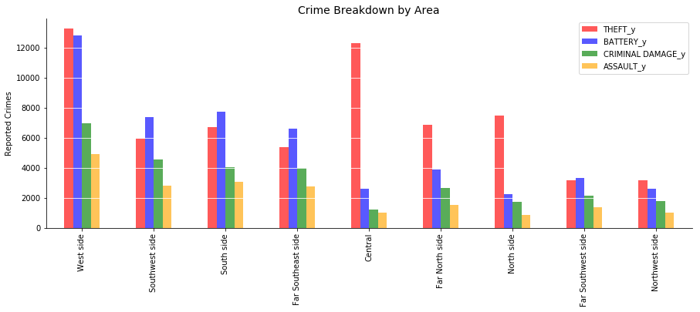

Figure

Chicago’s most dangerous areas are much higher in battery, criminal damage, and assault, whereas the safer areas of Chicago have a much higher proportion of theft-related crimes. Geographically, this can be seen below in *Figure 13.*

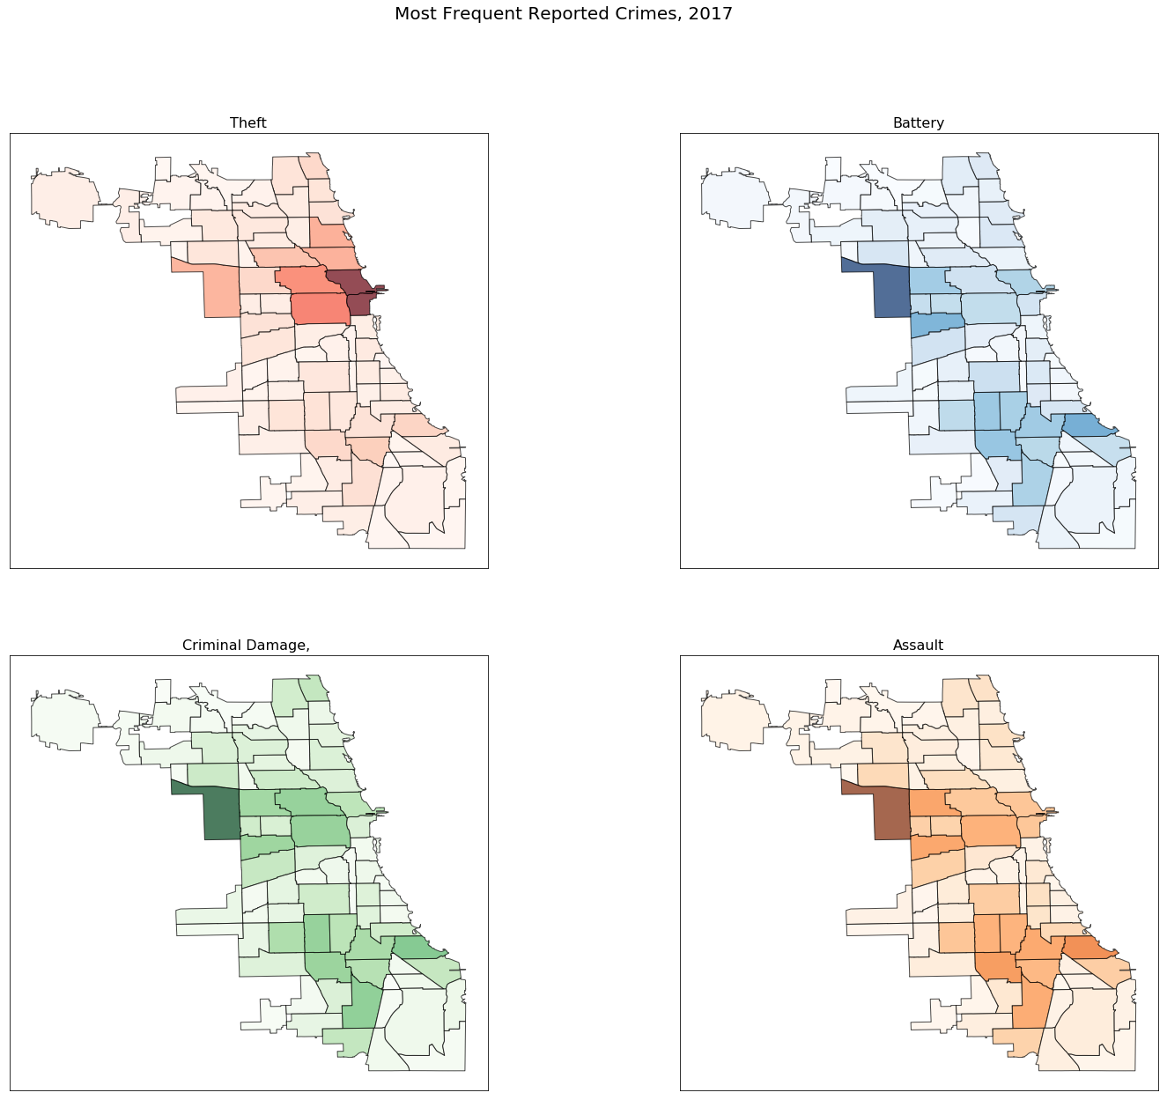

Figure

Finally, I wondered if there was any pattern in when crimes occur. Originally, I thought that more crimes may occur in winter, as people are likely more distressed and there are fewer hours of sunlight. However, when looking at daily arrests in 2017, as shown in *Figure 14*, there are minimal seasonal patterns in the arrest data.

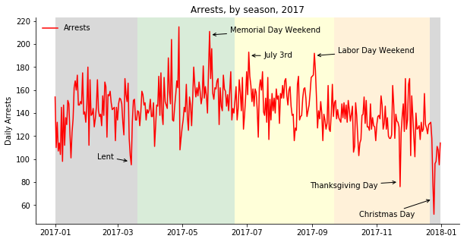

Figure

Holidays, however, have a huge impact on crime. The three days of the year with the fewest amount of arrests were Lent, Thanksgiving Day, and Christmas Day; days upon which most are spending time at church or with their families. Holidays also correlated to local peaks in arrests, as Memorial Day weekend, July 4th, and Labor Day Weekend all saw huge increases in arrests.

1. **A Brief Look into Drug Arrests in 2017**

As stated early, many civil-rights activists commonly claim that drug arrests impact minorities and low-income communities disproportionately. I decided to look at the arrest data specifically for the smallest amount marijuana possession, as studies have shown that whites and Blacks throughout America typically use marijuana at the same rate. Thus, we should expect to see arrests for marijuana possession equally distributed amongst Black and white communities.

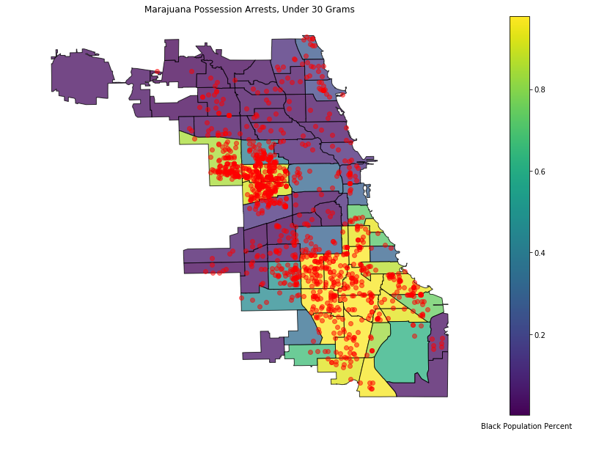

Figure

*Figure 15* shows a much different story. Marijuana possession arrests, like most other crimes discussed in this report, seem to be strongly clustered amongst Chicago’s western and southern communities. Moreover, arrests for possession of small amounts of marijuana seem to be particularly high in communities with a large proportion of Black residents. This would imply that Black communities are in fact being disproportionately arrested for marijuana. However, I still wanted to look closer into this. Thus, I classified each Chicago community as either a “minority” community, that is a population that is less than 50% white, or a white-majority community.

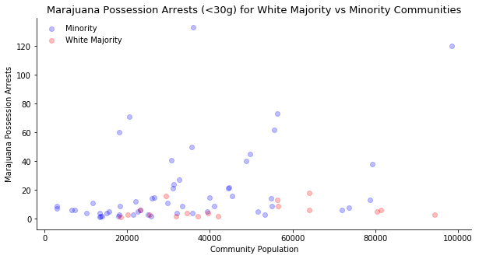

Figure

I was actually surprised at how clear the difference is in these communities. The only communities with high amounts of marijuana possession arrests are those that are have a majority non-white population, regardless of the community’s population. To confirm, I looked at the data one more way: by plotting marijuana arrests in a community by the community’s percentage of non-white residents (*Figure 17)*.

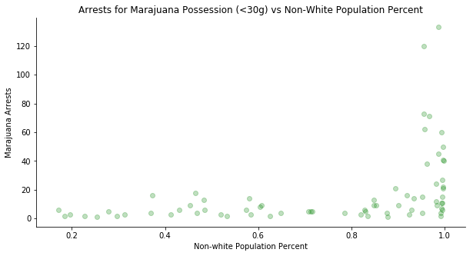

Figure

The plot shows a similar pattern: the only communities with large amounts of arrests for small amounts of marijuana possession are those that have close to a 100% non-white population. It is a huge problem for our society when there is such a drastic difference in arrests for minorities vs white people, especially for non-violent crimes. Finally, I looked at the geographic distribution of the other most prevalent drug offenses, to see if the same pattern exists with other drugs.

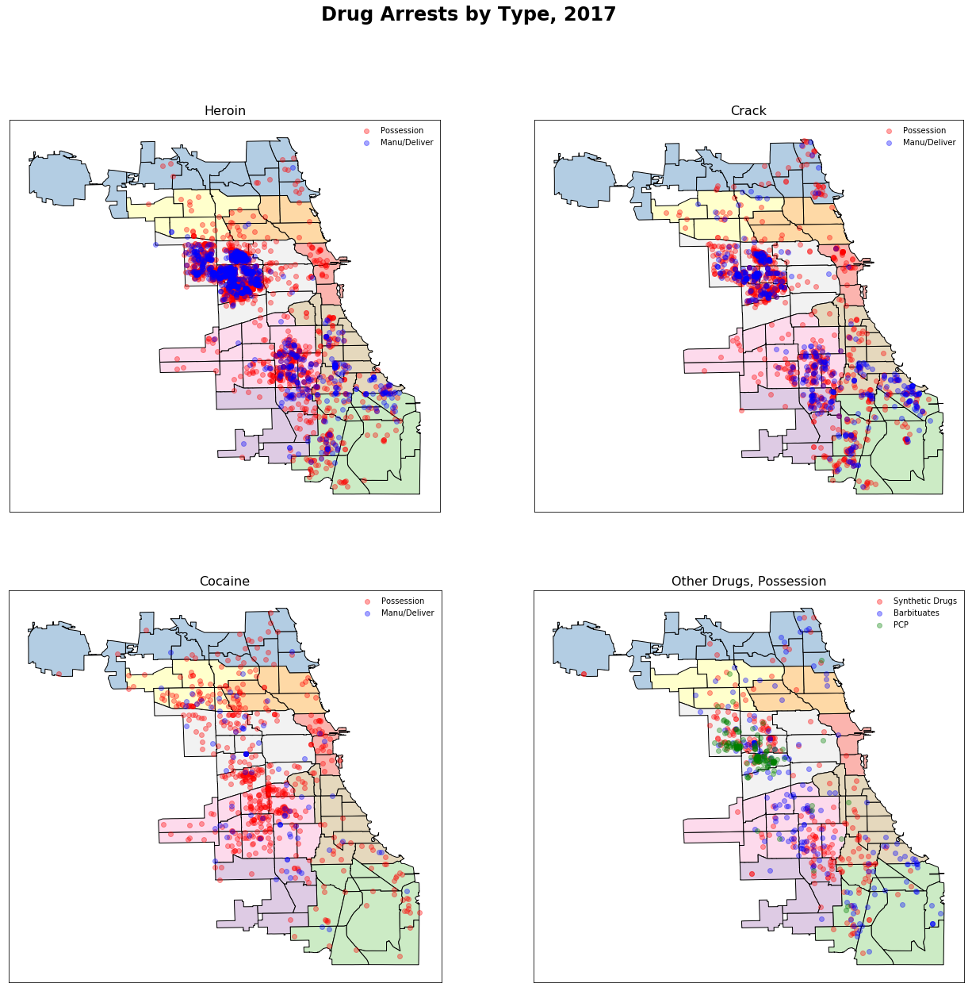

Figure

*Figure 18* shows the distribution of heroin, crack, and cocaine arrests, for both possession and manufacturing/delivering. Heroin, crack, and other miscellaneous drugs had similar distributions as marijuana, as they are almost exclusively found in Chicago’s west and southern communities, where there is a larger minority population. In fact, crack and heroin have nearly identical distributions, and it looks like both a primarily distributed in the West side of Chicago, particularly Austin and North Lawndale. Cocaine is distributed much differently, as there are few arrests in the areas that crack and heroin are most prevalent, and are instead more common in the northwest and southwest communities. This makes sense, as crack is often seen as a cheaper alternative to cocaine, and we see that in the poorest southern and western communities, crack is much more apparent than cocaine.

**Conclusion**

From the data, I was able to gain great insight into how crime is distributed in Chicago, and how it has changed over time. First, contrary to the president’s comments, we saw that both violent and non-violent crime rates have steadily decreased in Chicago this century, as have arrests. While drug offenses are still the most common type of arrest, the amount of drug arrests have greatly decreased over that time, leaving theft, battery, and trespassing as the most common reasons for arrest in Chicago today.

I also learned how the geographic and socio-economic breakdown of Chicago impacts Chicago’s crime rate. All of the communities with high amounts of crime came from poor communities on Chicago’s south and west sides, and also had a higher minority population. Specifically, crime rate and poverty have a clear positive relationship, whereas there is also a clear relationship between poverty rates and minority populations in Chicago’s communities. In addition I learned that this is minimal seasonal impact on crimes in Chicago, yet holidays cause the amount of arrests to greatly fluctuate.

Finally, I learned just how disproportionate arrests are for marijuana possession, as the only communities that see large amounts of arrests for this offense are those that have nearly 100% non-white population.

There is a great amount of further analysis that can go into this report, and there was some that was already taken out of this report due as this report was already much too long. However, things I am particularly interest in are ways to combat crime – specifically looking at whether “Stop and Frisk” helped reduce crime when implemented in New York city. Another analysis I am interested in is whether legalizing all drugs (as Portugal did at the beginning of the century) would be beneficial.

**References**

1. <https://www.chicagotribune.com/news/ct-trump-chicago-police-crime-met-20160823-story.html>
2. <https://twitter.com/realDonaldTrump/status/752834632907943936?ref_src=twsrc%5Etfw%7Ctwcamp%5Etweetembed%7Ctwterm%5E752834632907943936&ref_url=https%3A%2F%2Fwww.chicagotribune.com%2Fnews%2Flocal%2Fbreaking%2Fct-trump-tweets-quotes-chicago-htmlstory.html>
3. <https://ips-dc.org/criminalization-of-race-and-poverty/>
4. <https://www.naacp.org/criminal-justice-fact-sheet/>
5. <http://www.ilga.gov/legislation/ilcs/fulltext.asp?DocName=074000450K2>